**תרגיל למערכת טביעת אצבע**

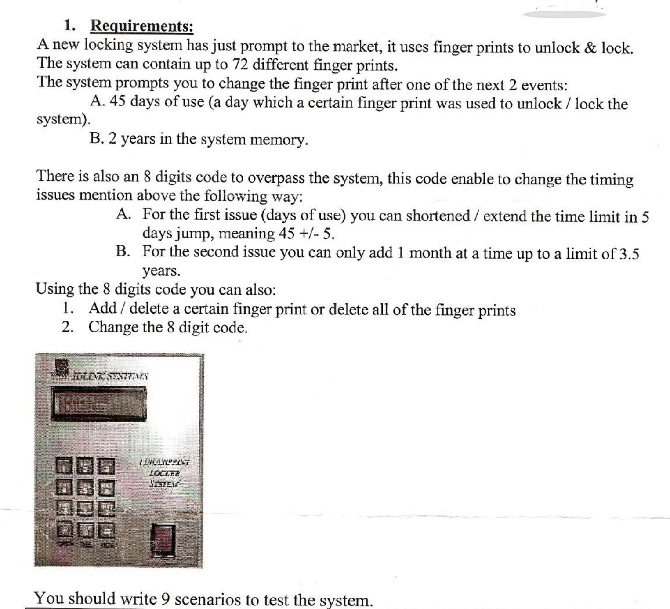

|  |
| --- |
| I will test the option to unlock and lock the system with an authorized fingerprint. |
| I will check that I’m unable to unlock and lock the system with an unauthorized fingerprint. |
| I will check if I’m able to save 72 fingerprints into the system. |
| I will check the system’s behavior when I try to add another fingerprint to the system after I already reached the capacity of 72 fingerprints.  A good scenario will be an error message along the lines of: “The maximum capacity of saved fingerprints has been reached”. |
| I will test the system using the same fingerprint for 45 days and check if the system will prompt m to change the fingerprint |
| I will check if the system prompts me to change my fingerprint after 2 years of it being saved in the system |
| I will enter the 8 digits code and check if I can shorten and extend the time limit in 5 days jump (for the issue of 45 days of using the same fingerprint) |
| I will test the same fingerprint from the test case above and check if I’m able to unlock and lock the system during the extended and shortened time limit |
| I will enter the 8 digits code and check how the system behaves when I try to shorten and extend the time limit for more than 5 days jump. I expect to get an error message along the lines of: “Please enter a number between 1 and 5 only” |
| I will use the 8 digits code and will try to add a month to the maximum 2 years of system memory for a fingerprint until I reach 3.5 years limit |
| I will test the same fingerprint from the test case above, and check if I’m able to unlock and lock the system during the extended period of time, focusing on the 2.1 and 3.5 years |
| I will check how the system behaves when I try to add one more month to the system memory limit after I extended it to the limit of 3.5 years. I expect to get an error message along the lines of: “You have reached the maximum limit of 3.5 years” |
| I will check if I can extend and shorten the time limit of 45 days without the 8 digits code and test the behavior of the system when I try to do it. I expect to get an error message along the lines of: “Access denied. Please enter 8 digits code”. |
| I will check if I can add more months to the time limit of 2 years without the 8 digits code and test the behavior of the system when I try to do it. I expect to get an error message along the lines of: “Access denied. Please enter 8 digits code”. |
| I will check if I can add a fingerprint using the 8 digits code |
| I will check if I can delete 1 fingerprint using the 8 digits code |
| I will check if I can delete all the saved fingerprints using the 8 digits code |
| I will check how the system behaves when I will try to delete a fingerprint without the 8 digits code. I expect to get an error message along the lines of: “Access denied. Please enter 8 digits code”. |
| I will check if the 8 digits code allows me to change the 8 digits code |
| I will check how the system behaves when I try to change the 8 digits code without entering the 8 digits code first. I expect to get an error along the lines of: “Access denied” |
| I will check if the system looks the same as described in the document, including the colors, fonts, size, etc |
| I will test the usability of the system - is the system user-friendly? Is the system easy to understand by the standard person? Is the functionality of the system very clear? is it intuitive? I will let a test group use the system and give their opinions on their experience |
| I will check that the system can be operated by handicapped people.   * I will suggest implementing brille on the buttons to make the system accessible for visually impaired users. * I will suggest implementing at least partially a voice-over program for the error and success messages to aid the visually impaired users |
| I will check how the system behaves if it shuts down unexpectedly and I turn it back up. I will check that the saved fingerprints are still in the system and that the functionality of the system is still working correctly. I expect that nothing was erased while the system was shut down |
| I will test the performance of the system and check the response time. Response time of more than 3 should be considered a bug |
| I will test how the system reacts to load testing - adding multiple fingerprints, deleting multiple fingerprints, unlocking and locking the system multiple times |
| I will check the durability of the system while applying high pressure to the buttons, fingerprint scanner, and the screen |